FTF FY 2023 Performance Scorecard USAID Senegal

This Feed the Future (FTF) Performance Scorecard assesses the USAID Senegal progress toward FY 2030 Performance Targets.

# Performance Overview



The FY 2023 **On track** value is determined by drawing a line from the baseline (FY 2022) to the FY 2030 Target. For FY 2023, Performance Targets are considered **On track** if they have reported at least 90% of that value.

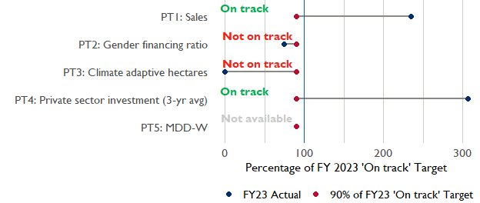

**Note:** *For Performance Target 2 (Gender financing ratio), the target is to increase financing to females for those OUs that are already achieving parity ($1).*

*For Performance Target 4 (PSI), all targets are relative to the last three years’ reporting. In future years, the interim targets may increase.*

*For Performance Target 5 (MDD-W), all FY23 actual values are also the baseline, and may have been collected in a prior year. See the detail page for more information.*

*See detailed* [*methodology document*](https://docs.google.com/document/d/13n-43ppFiGKauscQ7HaAiQDCM4DssGEgRdq2fMyTDn0/edit) *here. If you have questions, please email the FTF Data and Analytics team at* [refs.adl.da@usaid.gov](mailto:refs.adl.da@usaid.gov).

### Performance Target (PT) Details

This section shows PT scores for each applicable PT for USAID Senegal.

## Performance Target 1: Value of annual sales of producers and firms receiving USG assistance



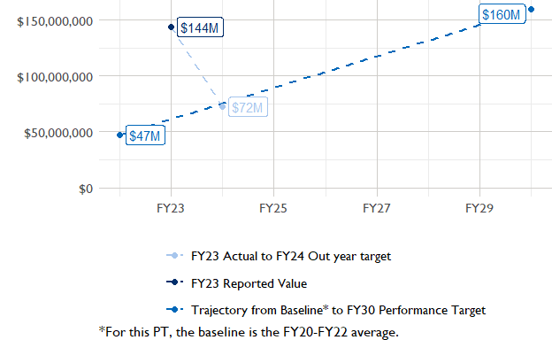

In FY 2023, USAID Senegal had 8 activities that aligned the ‘Value of annual sales from producers and firms receiving USG assistance’ (EG.3.2-26), and 5 contributed to the sales total of $143,680,000.  
Note that while USAID Senegal was ‘On track’ in FY23, it expects a substantial decrease in FY24. Such an increase would make it ‘Not on track’ for this performance indicator.

###### Performance Target 2: Value of financing accessed by female FTF participants per $1 of financing accessed by male FTF participants



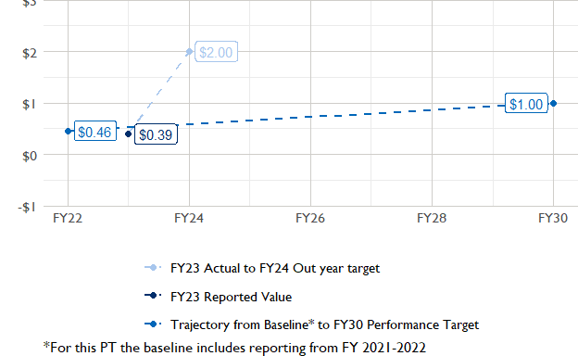

In FY 2023, USAID Senegal had 2 IMs/Activities that reported all four sex disaggregates needed to contribute to PT2. The total value of financing among all activities, regardless of disaggregates, was $25,720,000 (EG.3.2-27 total), with $25,720,000 that was disaggregated by females and males, and an additional $3,670,000 to ‘mixed’ firms that have both males and females, and $10,640,000 that was not sex disaggregated.  
Note that while USAID Senegal was ‘Not on track’ in FY23, it expects an increase in FY24. Such an increase would make it ‘On track’ for this performance indicator.

###### Performance Target 3: Number of cultivated hectares under climate adaptation/climate risk management practices and technologies with USG assistance



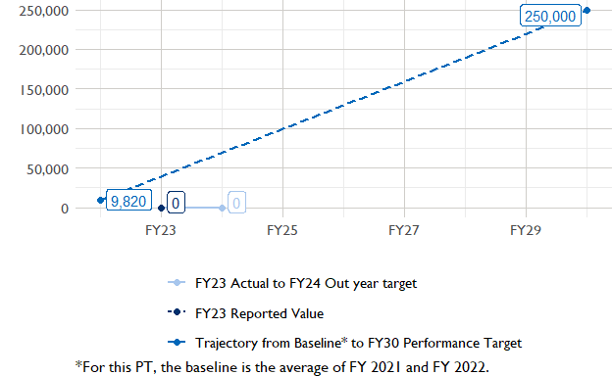

In FY 2023, USAID Senegal had 19 activities that aligned the indicator for hectares under improved management practices (EG.3.2-25). Of those activities, 0 reported on the ‘Climate adaptation/climate risk management’ disaggregate and contributed to the OU total for this PT.

###### Performance Target 4: Value of private sector investment leveraged by the USG to support food security and nutrition



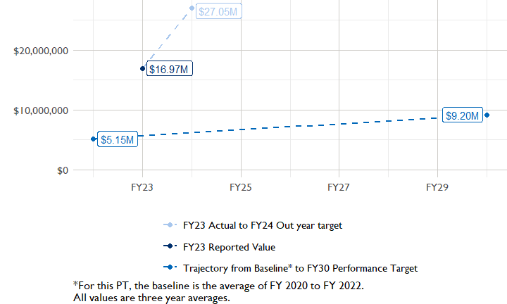

In FY 2023, USAID Senegal had 4 activities that aligned the private sector investment indicator (EG.3.1-15/-14), ‘Value of new private sector investment leveraged by the USG to support food security and nutrition [IM-level]’, and 4 contributed to the OU total in FY 2023.

###### Performance Target 5: Percent of women consuming a diet of minimum diversity (MDD-W)



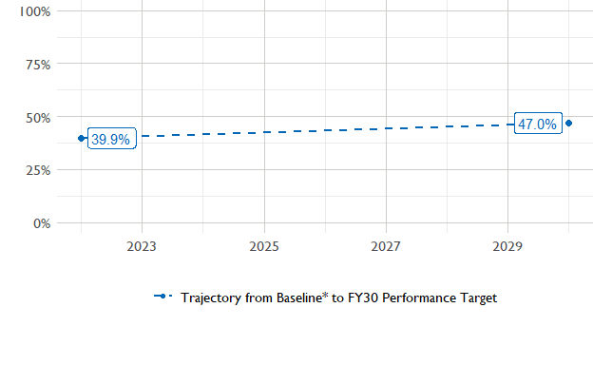

The baseline population-based survey (PBS) for USAID Senegal was in 2022 and showed that 40% of women in the ZOI had consumed a minimally-diverse diet in the previous day or night. The FY30 target is 47% percent. The following PBS is scheduled for .

### National Context

National level data was collected from the [World Bank’s Open Data portal](https://data.worldbank.org/) that measures key indicators at the national level.

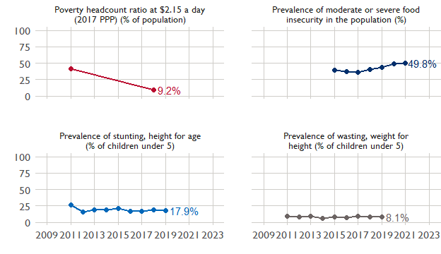

## Agricultural Transformation Index Score

The IFPRI Agricultural Transformation Index (ATI) Score is a high level indicator of the status of agricultural market systems in each country.

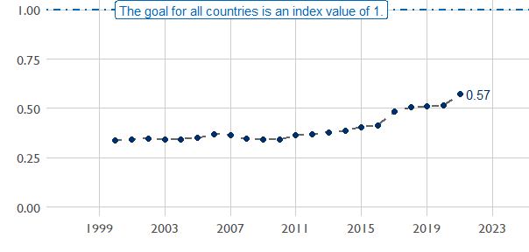

## Budget Trend

At the Operating Unit level, the Performance Targets are based in part on the FY 2024 budget request. The budget chart below includes EG.3 money only.

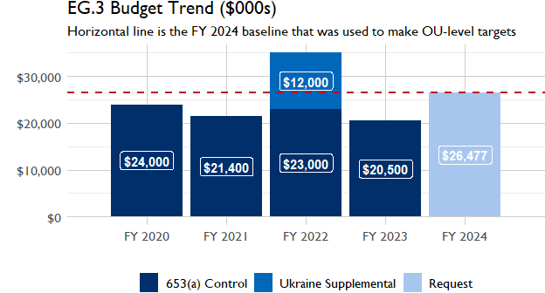

## Active Portfolio

The following activities are considered “active” based on their reporting in FY 2023 and expected FY 2024 reporting. The Analytics, Data and Learning Division defines an “active” activity as one that reported targets, actuals, or deviation narratives for the current year (FY 2023), or the next out year targets (i.e. FY 2024).

## Top Activities (Award Disbursements and Results)

This section highlights the 5 activities (out of the total 19 in the USAID Senegal (SENEGAL) portfolio) that have the highest level of FY 2023 annual disbursements and highest reported values for the relevant indicators. The first table below shows activities with the highest total transaction amounts. The columns to the right indicate if these activities are reporting on relevant PT indicators.

| Award Number | Activity Code | Activity Name | FY23 Disbursements | PT1 | PT2 | PT3 | PT4 |
| --- | --- | --- | --- | --- | --- | --- | --- |
| 72068519CA00002 | 1670 | Feed the Future Senegal Fisheries Biodiversity and Livelihoods (Dekkal Geej) | $1,417,877 | X | - | - | - |
| 72062418IO00001 | 1669 | FTF Senegal Dundël Suuf Fertilizer Project | $1,352,884 | - | - | - | X |
| 72068520C00001 | 2333 | Nafoore Warsaaji (Commercializing Horticulture - Small Business Applied Research (SBAR) Pilot) | $684,018 | X | X | - | X |

The next table (below) shows the activities that reported the highest values for the relevant PT indicators. The total disbursements are included, if available.

| Award Number | Activity Code | Activity Name | Total Disbursements | PT1: Sales | PT3: Climate adaptive hectares | PT4: PSI |
| --- | --- | --- | --- | --- | --- | --- |
| 72068519CA00002 | 1670 | Feed the Future Senegal Fisheries Biodiversity and Livelihoods (Dekkal Geej) | $1,417,877 | $85,100,000 | NA | NA |
| 72068522C00009 | 5322 | Feed the Future Senegal Value Chain Services Activity - Doolel Mbay | NA | $26,551,919 | NA | $1,559,777 |
| 72062019C00003 | 2968 | West Africa Trade and Investment Hub | $352,937 | $22,994,545 | NA | $22,376,476 |
| 72068520C00001 | 2333 | Nafoore Warsaaji (Commercializing Horticulture - Small Business Applied Research (SBAR) Pilot) | $684,018 | $8,977,403 | NA | $11,499,234 |
| 72068518T00001 | 2347 | Food Security Initiative (PAPA with Peace Corps) | $293,269 | $58,452 | NA | NA |

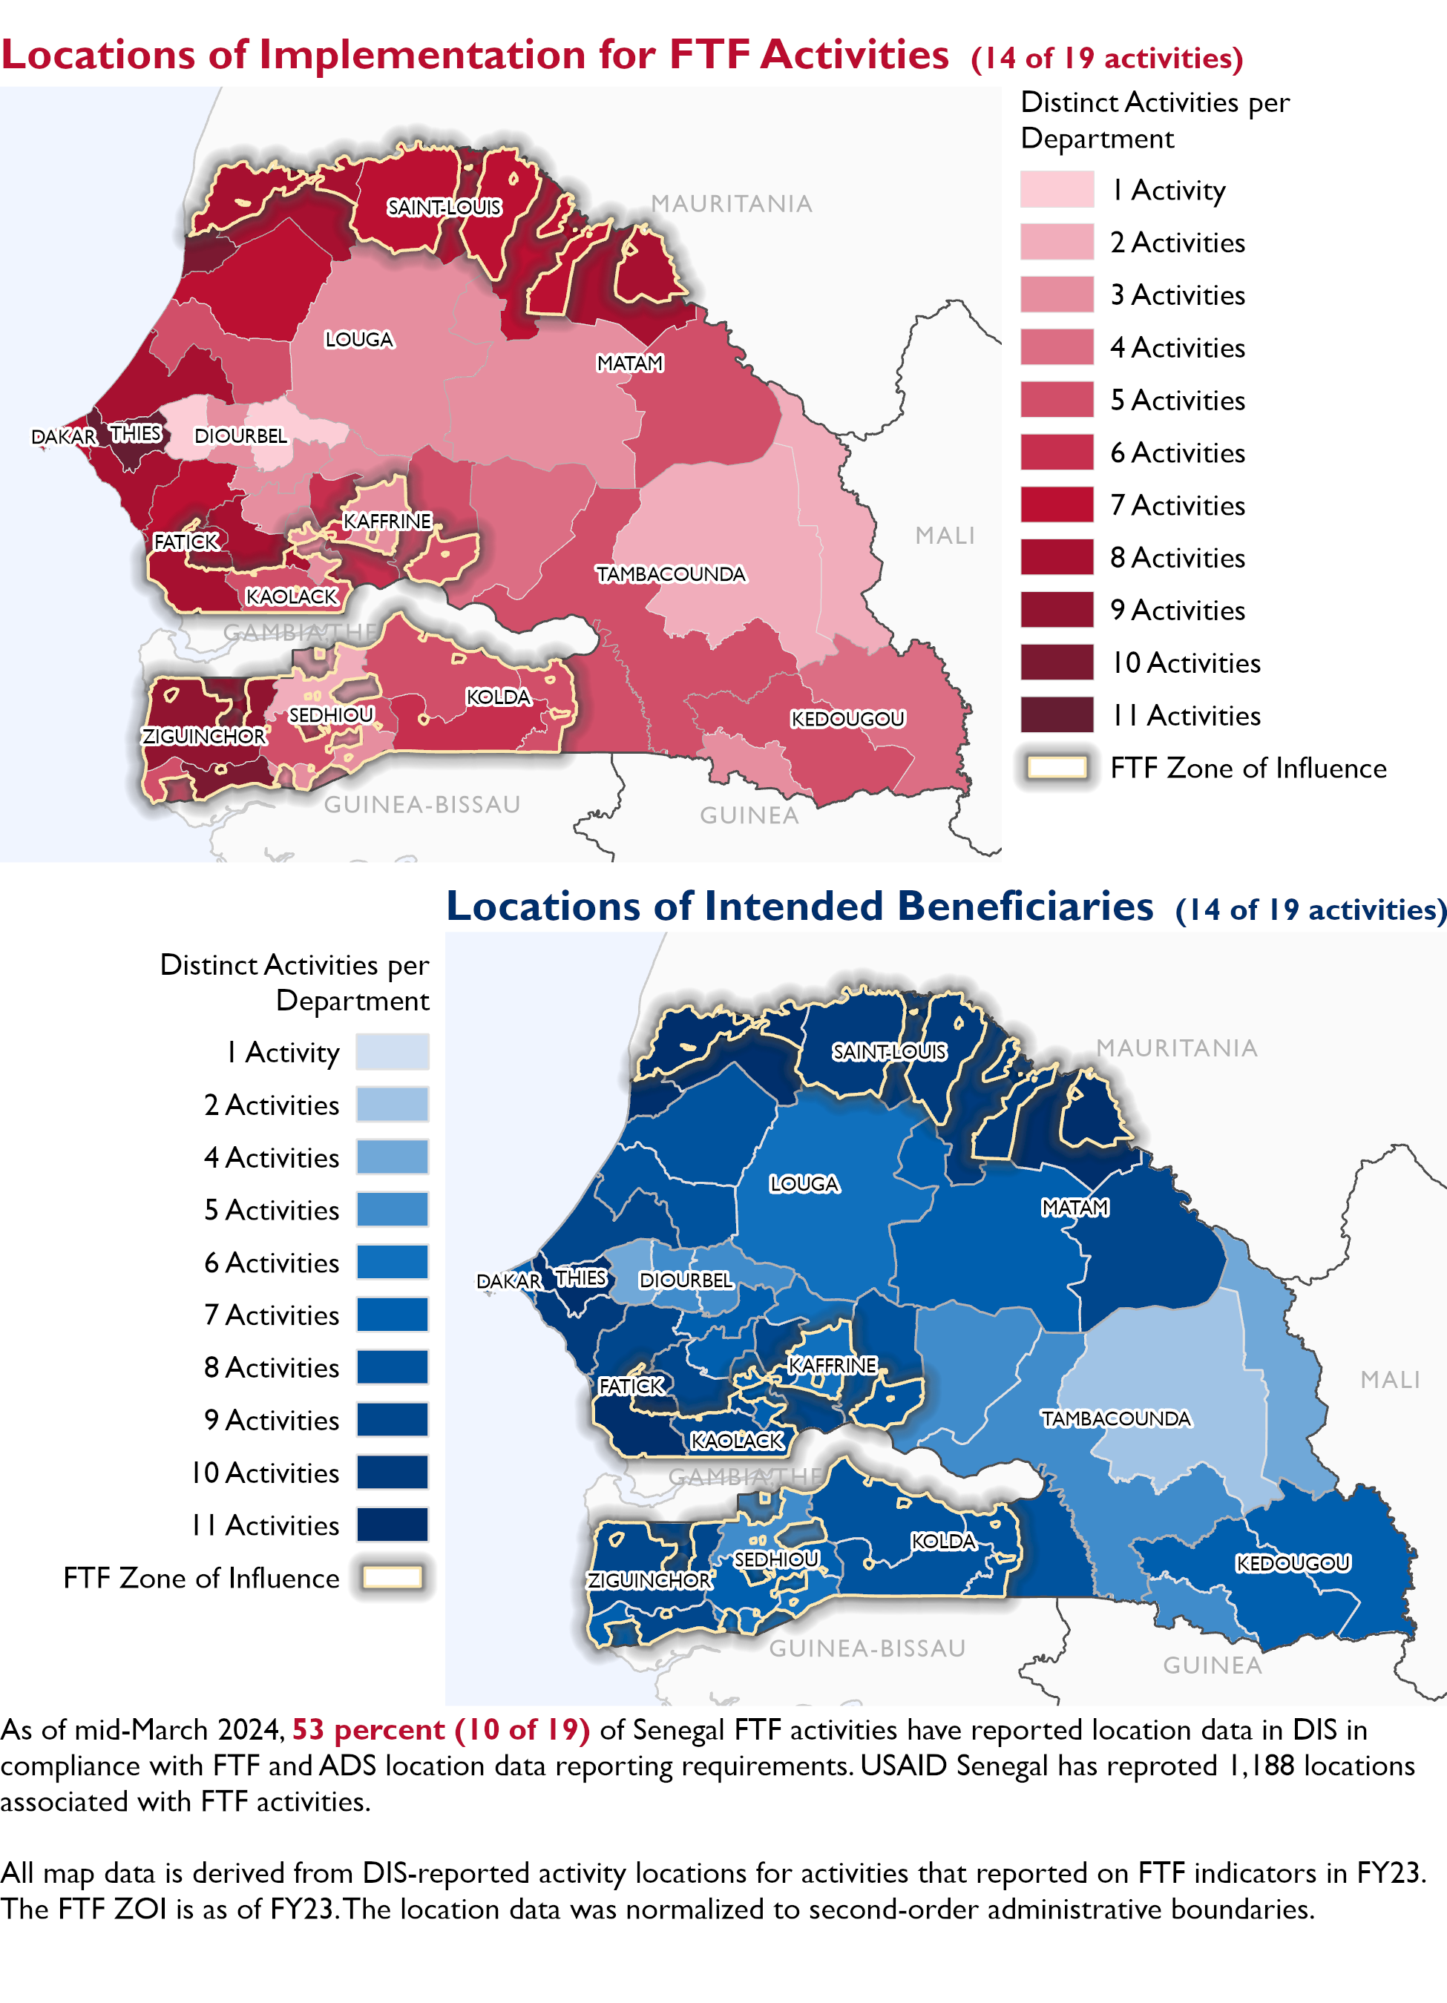

### Appendix 1: Response to “Not on track” Performance Targets

This section provides space for USAID Senegal to provide an explanation of why the following PTs are not on track and how you could adjust to be on track in the coming year(s). To help in your response(s), the relevant section of the FTF/GFS Key Issue Narrative (KIN) is provided, as it *may be* useful in drafting a responses. Note that the KIN is addressing the sum of the out year targets (FY 2023) set by the USAID Senegal activities that are reporting on each PT. The FY 2023 out year targets were set prior to the establishment of the FY 2030 Performance Targets, so the below explanations from the KIN may not apply to the Performance Target deviation.

* In Section 4 of the FTF KIN, your OU discusses FY24 and FY25 targets, while these Scorecards are addressing progress against a trajectory from historical reporting to your OU’s FY30 target. Also, the FY 2023 out year targets were set prior to the establishment of the FY 2030 Performance Targets. Therefore, the below explanations from the KIN may not apply to these FY30 Performance Target deviations.
* These responses will be used to compile a Congressional report, the GFSS Implementation Report, to discuss progress against the FTF FY 2030 Performance Targets, as mandated by the GAO.
* Only PTs that are ‘Not on Track’ require review and explanation from the OU.

Include the following two components in each response:

1. An explanation of why this target is not on track. Explanations may include that the OU/Mission was not aware of the target prior to planning activities. (Limit 100 words)
2. Planned actions for ‘not on track’ targets. Planned actions may include the launch of new activities, building awareness, holding portfolio reviews, or other suggestions. (Limit 100 words)

## Performance Target 2: Gender financing ratio [Not on Track]

*Excerpt from FY23 KIN Section 4 to consider:* received $20,586,808 while women only accessed $5,131,609. However, only one activity disaggregated the data and the results showed that the value of finance accessed by females per dollar of finance accessed by males (derived from EG.3.2-27) is 0.25 versus a target of 1. This deviation is partly due to an unrealistic target particularly for male dominant value chains such as irrigated rice. The former value chain activity sex disaggregation of EG.3.2.27 in 2015 had a value of 0.11 (FTFMS archive for Naatal Mbay and PCE). Pivots/Adjustments to be taken: The FTF Senegal baseline for this Performance Goal Indicator is 0.12 and the FY 2030 target is 1. An annual progression of 0.11 is now set for next year’s targets. Performance related to this indicator will be driven by the coming nutrition Locally Led Development Annual Program Statement activities (replacing former Kawolor), Nafoore Warsaaji, and Dooleel Mbay. The focus of the new GFSS country strategy on women economic empowerment will contribute to improved progress.

#### Enter USAID Senegal’s explanation of why this target is ‘Not on track’ below (Limit 100 words):

#### Enter USAID Senegal’s planned actions for ‘Not on track’ targets below (Limit 100 words):

## Performance Target 3: Hectares under climate adaptive and risk management practices [Not on Track]

*Excerpt from FY23 KIN Section 4 to consider:* target met (-2%) Deviation narrative : N/A Practices/Factors contributing to this performance : FY 2023 targets and performances were the results of three FTF activities: Dooleel Mbay, Nafoore Warsaaji and WATIH. Dooleel Mbay that represented 92 percent of the performance, supported adaptation and climate risk management for cereal and horticulture value chains by promoting drought, conservative agriculture, resistance seeds, access to climate information and to climate insurance. Nafoore Warsaaji also promoted climate insurance and facilitated the installation of 454 solar pumping kits, which reduced the high dependency on rainfall.

#### Enter USAID Senegal’s explanation of why this target is ‘Not on track’ below (Limit 100 words):

#### Enter USAID Senegal’s planned actions for ‘Not on track’ targets below (Limit 100 words):